
Work Instruction for RHEL 6 to 7 OS in place upgrade

Viatris
Work Instruction for RHEL 6 to 7 OS in place upgrade

Contents
Contents 2
1. Introduction 3
1.1. Purpose 3
1.2. Scope of this Report 3
1.3. Audience 4
2. Approach and Methodology 4
2.1. Approach 4
2.2. Methodology 5
3. Technical Details 5
3.1. Step 1 4
3.2. Step 2 6
3.3. Step 3 8
3.4. Step 4 10
3.5. Step 5 12
3.6. Step 6 12
3.7. Step 7 12
3.8. Step 8 12
3.9. Step 9 13
3.10. Step 10 13
4. Roles and Responsibilities 14
5. Escalation Matrix 15
6. Related Documentation 16
6.1. Additional Documentation on Known Issues 16
6.1.1. Filesystem Hierarchy Standard Failed: 16
7. Revision History 17

1. Introduction

1.1. Purpose
This document provides the steps to migrate the RHEL OS version from RHEL6.X to RHEL 7.6 or higher.

1.2. Scope of this Report

In Scope:
    - If OS version is going end of support, we will communicate it into Business and proposing OS upgrade to N-1 version release.
    - We will receive RITM from Application/ Database / Business unit for OS upgrade
    - If we receive email from Application/ Database / Business unit for OS upgrade, we will ask them to raise a RITM
    - We will raise a normal change and an update CMDB change, we will get approval, then will implement it.

Out of scope:
    - All server editions (except x86) of RHEL 6 can be upgraded with this procedure.
    - To check Proposed OS version is compatible to the database or the application.
    - Upgrading Database or application version to meet OS support version.
    - Business approval to upgrade OS, Application or Database
    - This procedure is not applicable for upgrading Amazon Web Services (AWS) instances or Amazon Machine Image or Microsoft Azure.
    - This procedure is not applicable for upgrading Cluster nodes.
    - This procedure excludes any system with 3rd party packages, especially those with 3rd party drivers that are needed for booting.
    - The server running on Physical hardware with local disk as boot volume and / partition will not applicable for OS in place upgrade.

1.3. Audience
GIDC Unix Group

2. Approach and Methodology

2.1. Approach
    - Download RHEL7.6 ISO image from Redhat support portal with valid login credential
https://access.redhat.com/downloads/
    - Before upgrading to RHEL 7, start with RHEL 6 and update your system to have the latest RHEL 6.10 packages installed.
    - Performing the in-place upgrade is not possible if the /usr/ directory located on a separate partition, because of system service requirement /usr/ directory should be reside / filesystem.
    - Register and subscribe the system with valid RHEL subscription to get latest update from Redhat.
    - Before performing the upgrade make sure you back up all of your data in order to avoid potential data loss. If it is a VM we have to take snapshot/clone. If is a Physical machine, we have to take Boot Volume Clone.
    - Make sure Change management was approved this activity and change is in approved for implementation.

Methodology

3. Technical Details
3.1. Step 1
Make sure you run the latest minor version of Red Hat Enterprise Linux 6 and have the latest packages,
    - Ensure the system was register and subscribed by
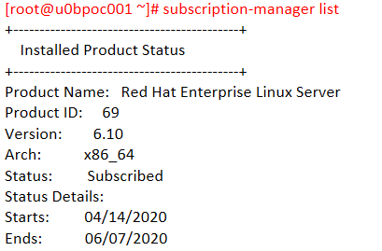
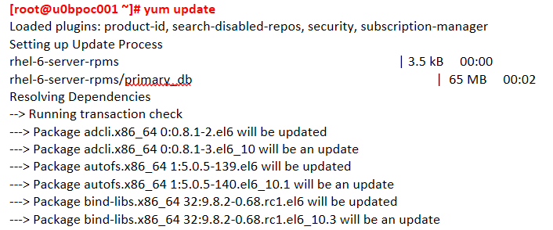
    - Install the latest update and patches from the last minor release of RHEL 6 by
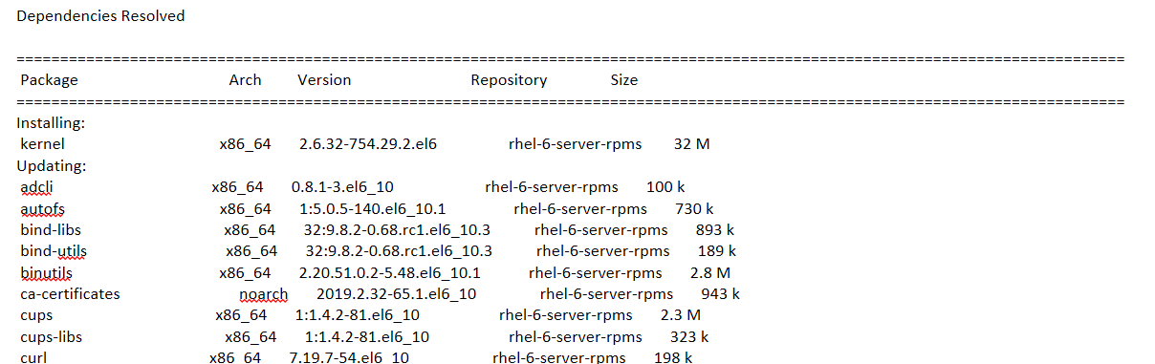
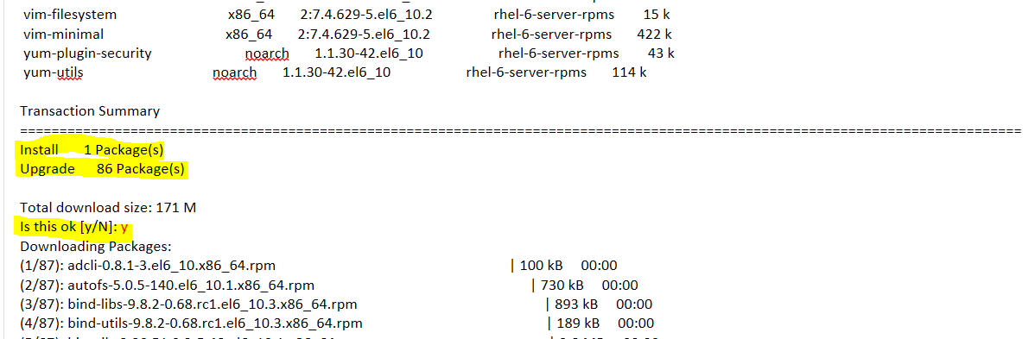
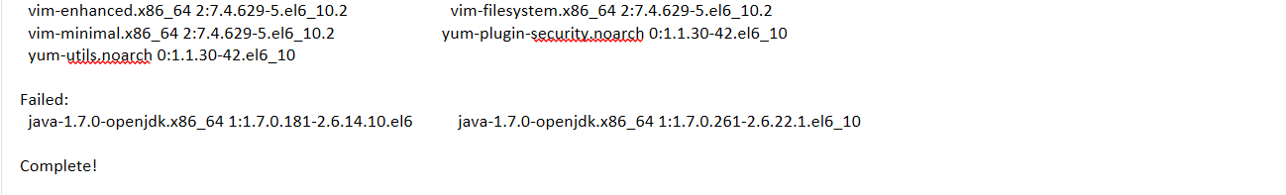
    - Reboot the server to take effect of applied patch

  - Step 2

Install the Preupgrade Assistant tool which helps you assess your system for any potential problems you might encounter with a Red Hat Enterprise Linux 6 to Red Hat Enterprise Linux 7 upgrade before any changes to your system are made.
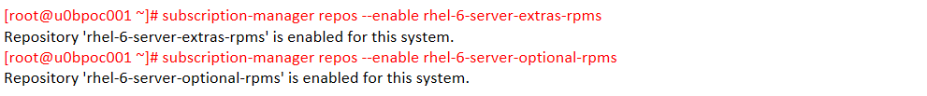
    - Enable the repository that contains the preupgrade-assistant, preupgrade-assistant-ui, preupgrade-assistant-el6toel7, preupgrade-assistant-el6toel7-data and redhat- upgrade-tool packages.

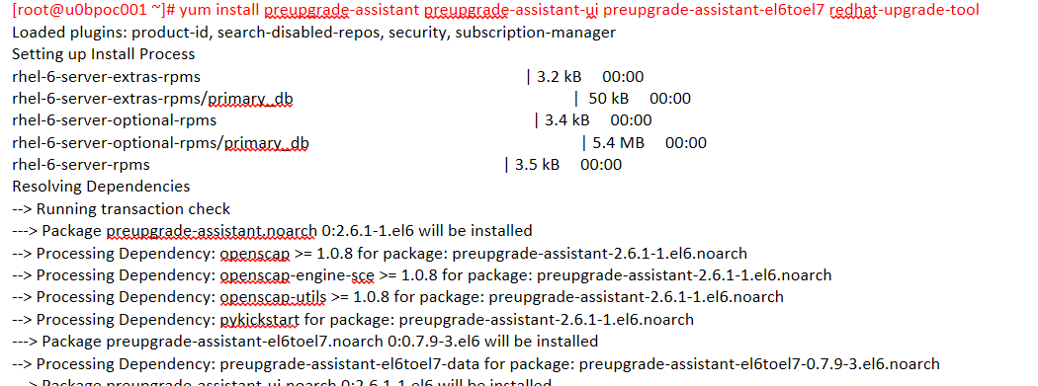
    - Install Preupgrade assistant utility by

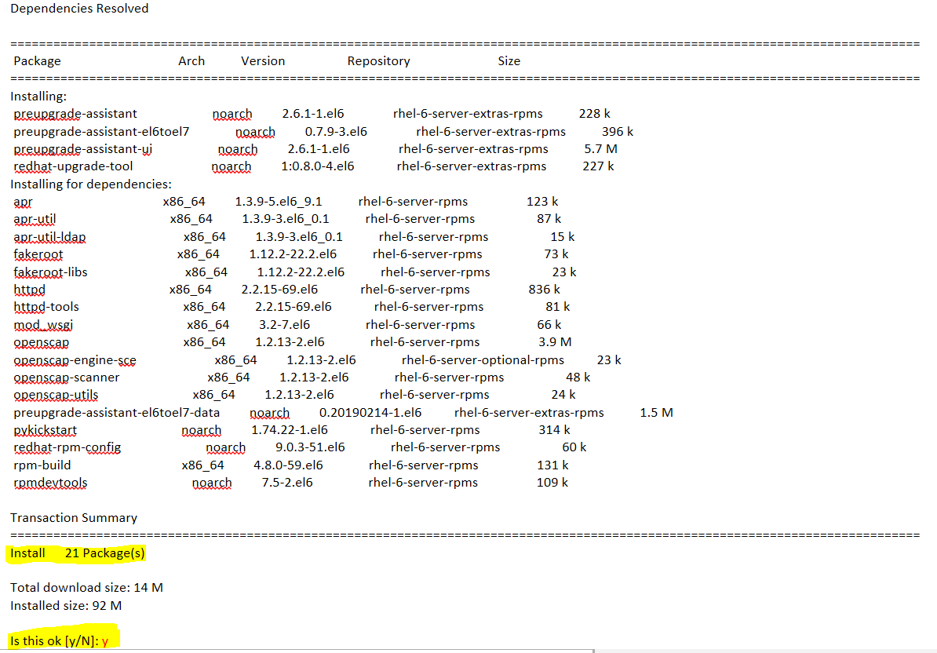
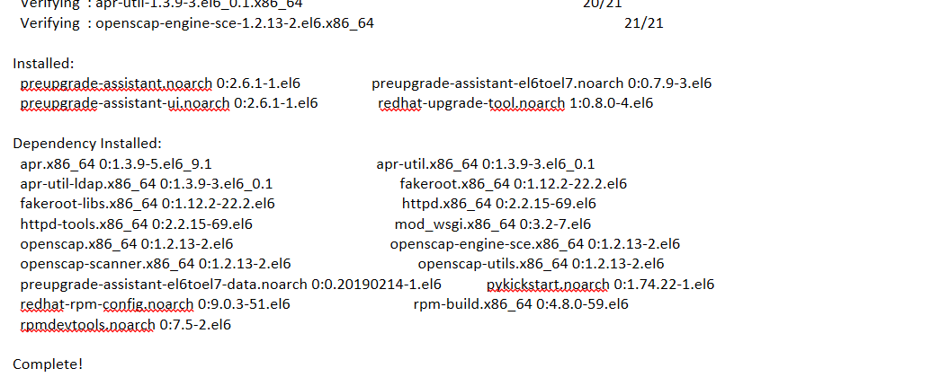

Step 3

Reviewing the system assessment results locally on the assessed system to fix the upgrade dependencies and issues.
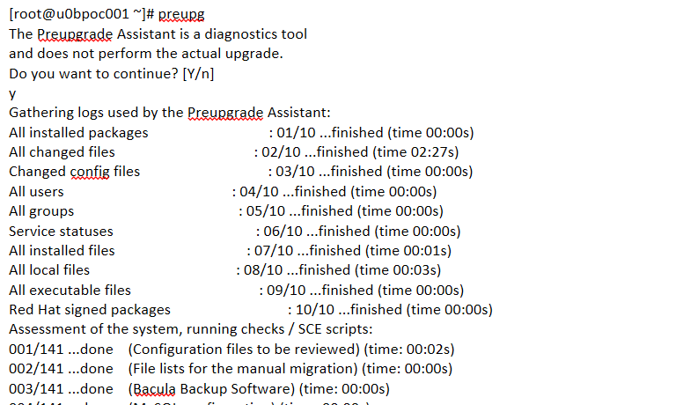
    - Run the preupg command to perform the assessment of the system LPAR.
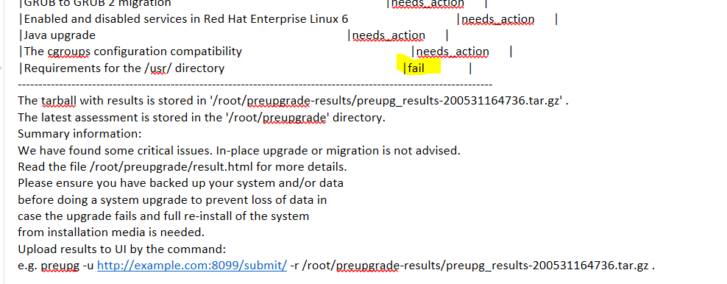
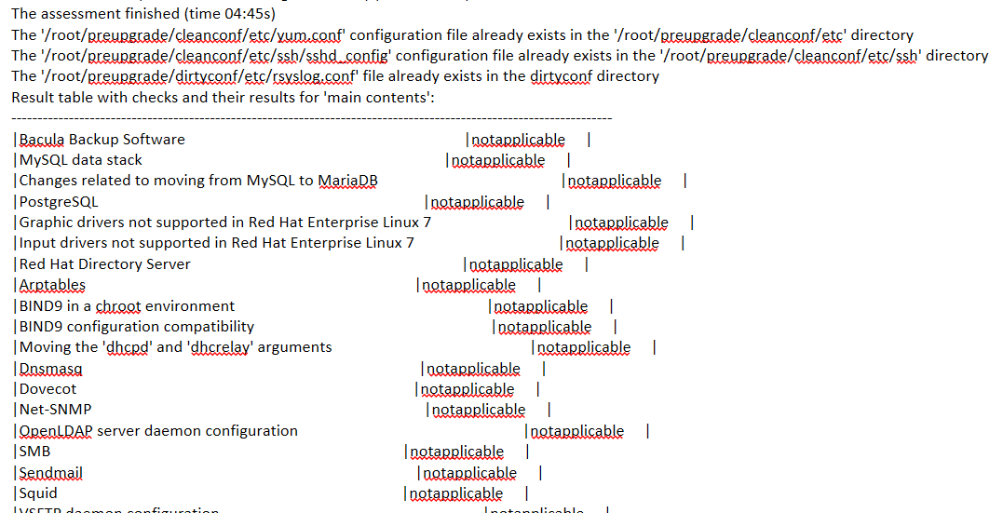

Note: Preupgrade Assistant Assesses the system for possible in-place upgrade limitations, such as package removals, incompatible obsoletes, name changes, or deficiencies in some configuration file compatibilities. It provides a report with the assessment result. It provides some postupgrade scripts to finish more complex issues after the in-place upgrade.
    - There is a README file in the output directory /root/preupgrade/. See the file for more information about the output directory structure, exit codes, and risk explanations associated with the preupgrade tool
    - Resolve the issues found by the Preupgrade Assistant during the assessment. There is a Solution text for each issue in the report, which should help you resolve the issue. Re-run the assessment again, and if there are no new issues to be resolved, continue to upgrade the system.

  - Step 4

Also you can view the assessment report from the Web UI, For that, we have to do below
    - Install the httpd package by
# yum -y install httpd preupgrade-assistant-ui
    - The Preupgrade Assistant Web UI is only available to the local system (127.0.0.1). To make it available to all network interfaces on the local system (TCP port 8099, by default)
# cd /etc/httpd/conf.d
# cp 99-preup-httpd.conf.public 99-preup-httpd.conf
# vi 99-preup-httpd.conf
~
NameVirtualHost u0bpoc001:8099
~
    - Restart the HTTPD service by,
# service httpd restart
    - Access the Preupgrade Assistant Web UI
    - The first time you access the Preupgrade Assistant Web UI, you are offered to add a user account, which can be used to gain access to the service, or disable the authentication feature. click on "Disable Authentication" and you can start using the graphical Interface.
    - Return back to the system you plan to upgrade. To perform the system assessment with an automatic submission of the result to the Preupgrade Assistant Web UI server
# preupgrade -u http://u0bpoc001:8099/submit/
    - Return to your Web browser on the remote system and access the Web UI again or just reload the page.
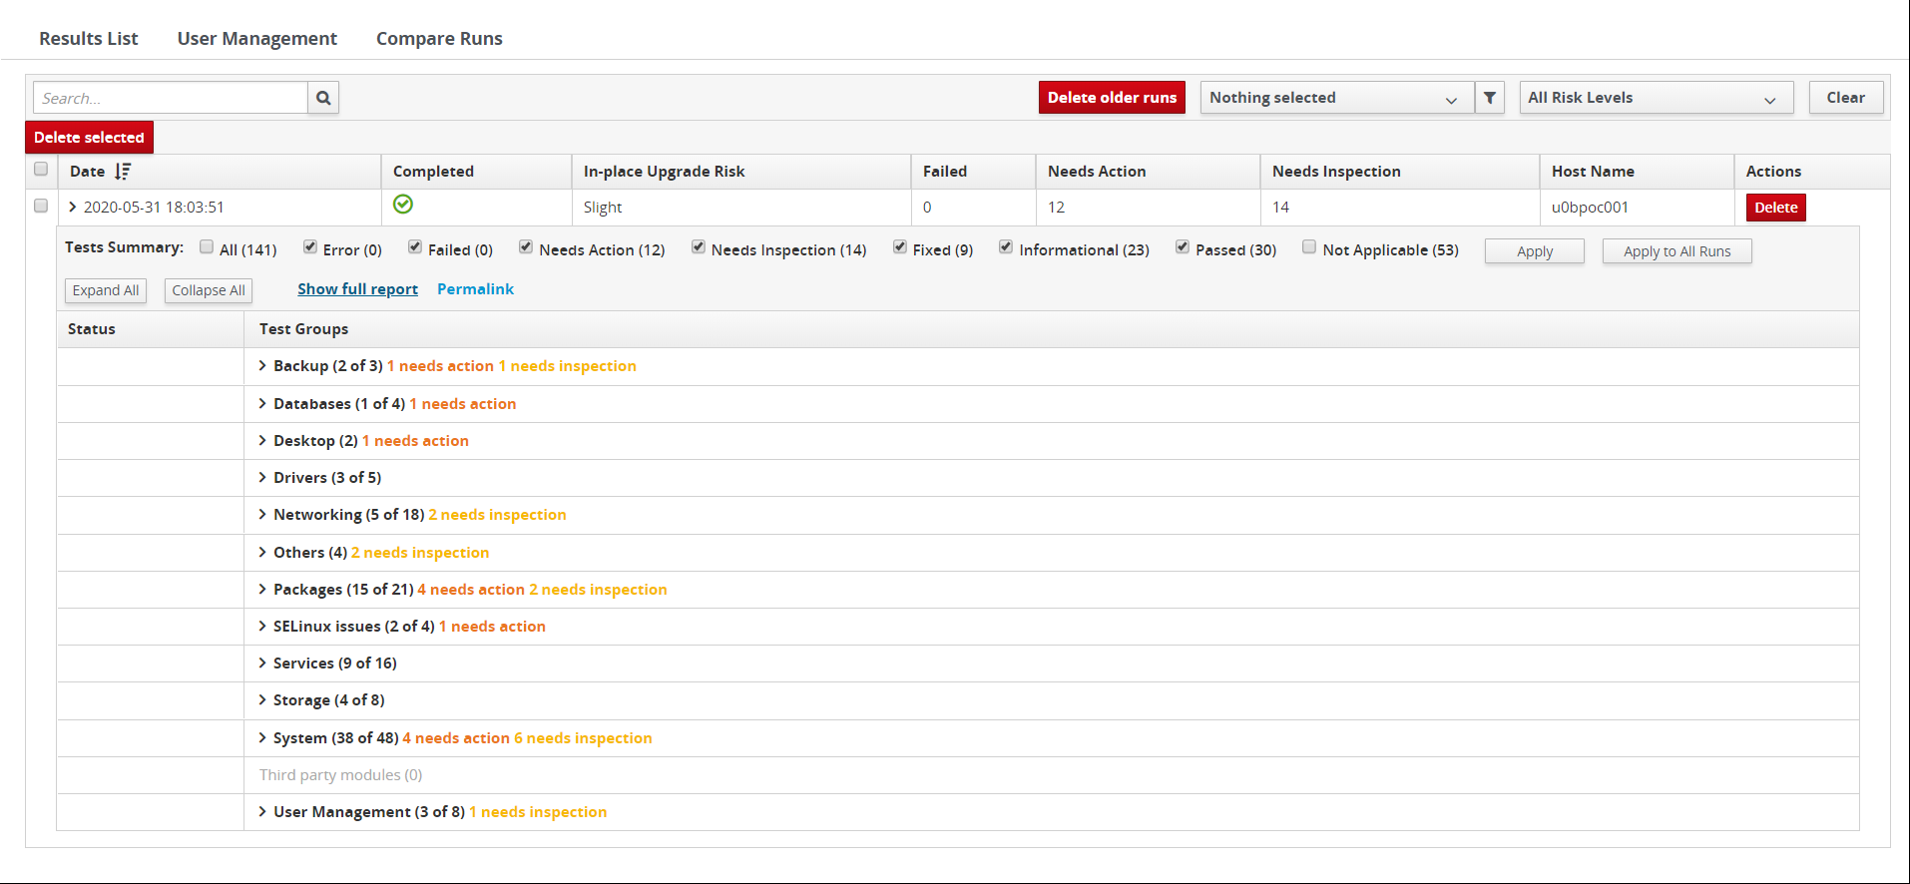

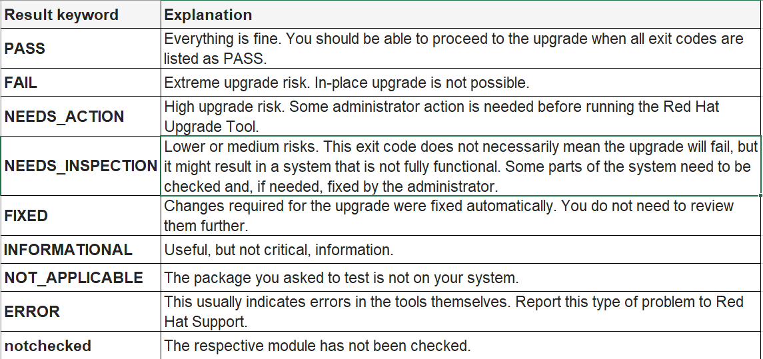

    - In the Web UI, find and expand the correct assessment report. Go through each item in the report and perform changes necessary to fix the reported issues. Then run preupg to assess the system again, upload the report to the Web UI, and if there are no new issues to resolve, proceed upgrade.

  - Step 5
Run redhat-upgrade-tool to download the packages needed to upgrade to Red Hat Enterprise Linux 7 and prepare the package installation.
    - Mount the Installation media on the system.
# mount /dev/sr0 /mnt
    - prepare the package installation by
# redhat-upgrade-tool --device /dev/sr0
NOTE: For the upgrade to work properly, you might need an access to software repositories beyond what is offered from the basic packages on the RHEL 7.6 DVD. In particular, the Extras repository in RHEL 7.6 contains some packages (mostly related to software development) that were in the RHEL 6 base system, but are not on the DVD. If you know that your upgrade requires packages (to meet dependencies) that are not in the RHEL 7.6 Base repository, you can install a separate RHEL 7.6 system to act as a yum repository to serve the packages you need over FTP or HTTP
# redhat-upgrade-tool --device /dev/sr0 --addrepo optional=http://host/repo
  - Step 6
To complete the OS Upgrade from RHEL6 to RHEL7.6, you need to reboot the system.
Note: After rebooting, depending on how many packages are being upgraded, it could take some time to complete. If everything goes as expected, the system will reboot to Red Hat Enterprise Linux 7.6, and you can begin checking that the system works properly.
  - Step 7

The scripts that have been created by the Preupgrade Assistant for the FIXED items will run automatically after the upgrade. Any other post-upgrade tasks that the administrator should run manually are identified in the Preupgrade Assistant report.

  - Step 8
Make sure that the system was upgraded to a RHEL 7 system, type:
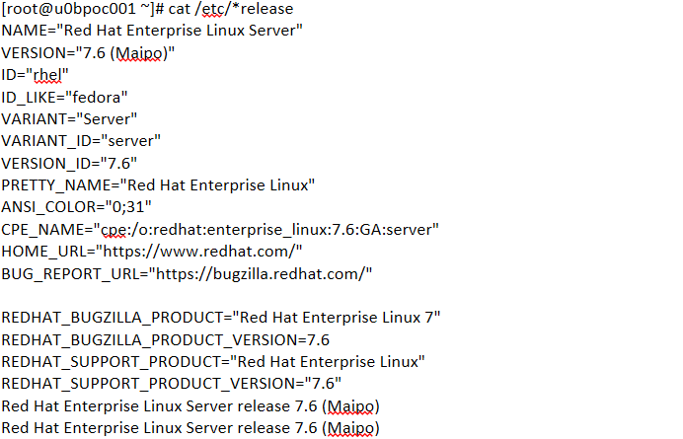
  - Step 9
If your system had been properly registered and subscribed for RHEL 6, the upgrade process should have automatically resubscribed it for RHEL 7.
  - Step 10
Upgrade tool is not capable of upgrading the GRUB Legacy configuration to GRUB 2 automatically. Since GRUB Legacy is not a supported solution on
Red Hat Enterprise Linux 7, you need to upgrade it to GRUB 2 manually
    - Ensure the following packages are installed and updated
# yum install grub2 grub2-tools grubby
    - Identify the boot device and install the GRUB2 in the correct boot device. In most of the RHEL system first disk is boot device
# grub2-install /dev/sda
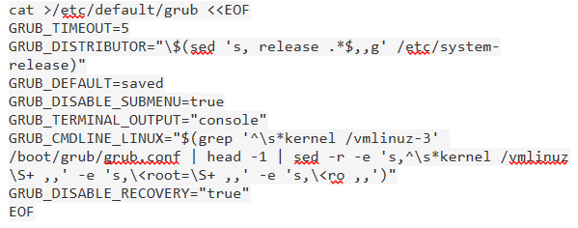
    - Create a good /etc/default/grub file by Execute the following commands verbatim as the root user

    - Once /etc/default/grub file get created, Inspect and/or customize the GRUB_CMDLINE_LINUX line before continuing, Build the grub configuration file by below command,
# grub2-mkconfig -o /boot/grub2/grub.cfg
    - Reboot the server with newly created grub. Post successfully reboot, remove legacy grub
# init 6
# rm -rf /boot/grub

Roles and Responsibilities
Sl. No. | Roles | Responsibilities | Team Member Name
1. | Maintenance Window | Respective Team / Unix Team | GIDC.unix_Run  GIDC.unix_Run@viatris.com
2. | Change Request | Respective Team / Unix Team | GIDC.unix_Run  GIDC.unix_Run@viatris.com
3. | Change Implementation | Respective Team / Unix Team | GIDC.unix_Run  GIDC.unix_Run@viatris.com
4. | Hyper Care | Respective Team / Unix Team | GIDC.unix_Run  GIDC.unix_Run@viatris.com

5. Escalation Matrix
Person Responsible | Role | Triggers When
Arun R  Arun.R@viatris.com  +91 9710677240 | SME
Ashok Kumar R K  AshokKumar.RK@viatris.com  +91 9967735890 | Manager
Mohandoss Murugesan  Mohandoss.Murugesan@viatris.com  +91 6366966170 | Senior Manager

6. Related Documentation

6.1. Additional Documentation on Known Issues

Filesystem Hierarchy Standard Failed:

Description: Performing the in-place upgrade is not possible if the /usr/directory located on a separate partition, because of systemd service requirement /usr/ directory should be reside / filesystem.

Solution:

Note: Make sure you back up all of your data in order to avoid potential data loss. If it is a VM we have to take snapshot/clone. If is a Physical machine, we have to take Boot Volume Clone.

Enter into rescue mode

Boot the system from the binary DVD

Once the system has successfully booted from the ISO image, the Red Hat Enterprise Linux boot screen will appear. Select Troubleshooting, then select rescue.

On rescue boot, select shell to get shell.

Unmount /mnt/sysimage/usr filesystem and other child filesystem if any # umount /mnt/sysimage/usr

Mount /dev/mapper/rootvg/usrlv to /mnt/usr

# mount -t ext4 /dev/mapper/rootvg/usrlv /mnt/usr

Rsync /mnt/usr to /mnt/sysimage/usr

# rsync -a /mnt/usr/* /mnt/sysimge/usr/

Comment out or remove /dev/mapper/rootvg/usrlv entry in fstab and grub.conf file if mentioned. Save and exit the file

# vi /mnt/sysimage/etc/fstab
Reboot the system.

7. Revision History
Date | Version | Summary of Changes | Author | Approved by
May 19 2021 | V1.0 | Updated Organization Detail | Franklin Kabila Dhas | Arunachalam G
Apr 5 2023 | V1.1 | Updated in New Template | Ashok Kumar RK | Mohandoss Murugesan
Dec 28 2024 | V1.2 | Validated the Document | Benesh Selva Nesan P | Arun R

